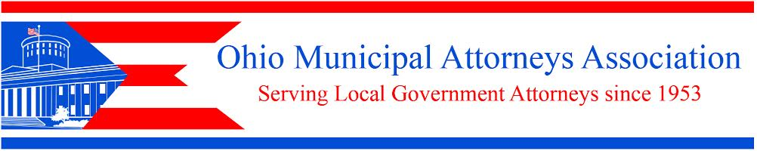
175 South Third Street, Suite 510, Columbus, Ohio 43215
Phone: 614-221-4349 Fax: 614-221-4390

REGISTRATION FOR OMAA/OML WEBINARS

PLEASE PRINT:

Municipality_______________________________________________

Address __________________________________________________

_________________________________________________________

Name of Law Director/Solicitor/Official___________________________

Email____________________________________Phone______________

______________ Session: Friday, July 8, 2016, 10 – 11 a.m.

COST: $75 per registrant (limit of 30 registrants per webinar session)
Your municipality counts as 1 registrant. You may have as many city officials (attorneys, mayors, council members, etc.) attend as you wish, for this $75 fee.

For our records we appreciate your advising us (cgrant@omlohio.org) how many officials you plan to have participate.

